

Faculty of Informatics and Computer Science
Software Engineering

Data Leakage Detection System

By: Mayar Ashraf 192785
Supervised By
DR. Marwa Salah

November 2022

Abstract
Data leakage is the unauthorized transaction from an internal agent in the organization to an external party. The most critical part of detecting a data leak is identifying the guilty agent before the data is leaked. In existing systems, fake objects were the approach to detect the guilty agent but the problem with this approach is that the guilty agent is detected after data is seen by an unauthorized party. Therefore, I have thought of modifying a data leakage detection system. The modified system will use the approach of fake objects with a new approach called audit log together to detect the data leakage beforehand. Furthermore, “the audit log also monitors user transactions and activities to computing resource at each stage of the process” [5]; so, the audit log approach will be located in a cloud platform that will constantly display a piece of descriptive information to visualize who, what, and when of an event to the administrator. So, the new system will use the concept of the fake objects to add it to the data before handing it to any agent and the audit log will have the code for the fake object to trace if any event contains this code and an agent is trying to send it to an unauthorized party, and the audit log will “safeguard the integrity, accessibility, and availability of data to authorized and authenticated users in cloud applications” [8]. Then, the system will alert the administrator who is the guilty agent by identifying the agent id, timestamp, and date stamp of the occurrence. Finally, the system will help in detecting data leakage before any unauthorized party has the audacity to use it.

Attestation &Turnitin Report
I understand the nature of plagiarism, and I am aware of the University’s policy on this.
I certify that this report reports original work by me during my University project except for the following:
- Figure 1 from google images.
- Figures 3 to 20 have reference [1] to [6] below each figure

Signature Mayar Ashraf Date 25 November 2022

Acknowledgements
I would like to thank DR. Marwa Salah for her constant support, feedbacks, and help to write this report professionally. Additionally, I would like to thank my family and friends for supporting me and giving me love and positive comments.
Contents

Abstract ii
Attestation &Turnitin Report iii
Acknowledgements iv
List of Figures vi
List of Tables vii
1 Introduction 1
1.1 Overview 2
1.2 Problem Statement 2
1.3 Scope and Objectives 2
1.4 Report Organization (Structure) 3
1.5 Work Methodology 4
1.6 Work Plan (Gantt Chart) 5
2 Related Work (State-of-The-Art) 6
2.1 Background 6
2.2 Literature Survey 6
2.3 Analysis of the Related Work 7
3 Proposed solution 22
3.1 Solution Methodology 22
3.2 Functional/ Non-functional Requirements 22
4 Conclusions and Changes 24
4.1 Summary 24
4.2 Changes 24
References 25

List of Figures
Figure 1 Waterfall Methdology steps 4
Figure 2 Gantt chart 5
Figure 3 [1] Propsed System 7
Figure 4 [1] Propsed System 7
Figure 5 [1] Explicit Data request 8
Figure 6 [1] Sample Data request 9
Figure 7 [1] Sample Data request 9
Figure 8 [1] Results of guilty agent probability 9
Figure 9 [2] Data requests 10
Figure 10 [2] E-optimal algorithm for explict request 10
Figure 11 [2] Sample data request 11
Figure 12 [3] E-optimal algorithm 12
Figure 13 [3] S-max algorithm 12
Figure 14 [3] System layout 13
Figure 15 [4] Data allocatin algorithm 14
Figure 16 [4] Algorithm for fake object module 15
Figure 17 [5] System architecture 16
Figure 18 [5] Graph of entries without Audit trail 16
Figure 19 [5] Graph of entries with Audit trail 17
Figure 20 [6] Proposed system algorithm 18

List of Tables
Table 1 Advantages and Disadvantages 19
Table 3 [7] Comparative study 21

Introduction
Preventing data leaks can be formulated with different solutions, either securing data beforehand or detecting the leakage. This report will focus on detecting data leakage and building a cloud platform to manage and visualise the data flow. Regarding the detection functionality, the starting point will be the fake object, which is the process of adding fake objects to different data and distributing them to different agents. When the data is seen to be on the verge of being leaked, the admin checks which fake object is on this data and which agent was given this fake object; finally, we know who the guilty agent is. Additionally, I will be creating a cloud-based application for companies to use to store, access, view, and share data via the internet or offline. The application will allow the employee to log in using a predefined username and password assigned by the administrator, and the data will be sent by the admin to the authorized employees. The data will be distributed to the agents and employees by the distributor, admin. The data will be injected with fake objects that act as watermarks and appear realistic to the agents; those fake objects have a high percentage of chance of detecting the guilty agent. Moreover, I will use the audit log which will track a specific action, and the action will be specified by the admin, which will be the fake objects used in the data. Each fake object will be preauthorized for a specific agent. If an agent attempts to share outside the organization, the agent's username and the date and time of the action will appear in the audit log as sent to an unauthorized person, a fake object of the data will appear in the audit log, and the admin will be notified via the application and email with the agent's username and the date and time of the action. As a result, the audit trail will be used as an agent guilt model, with a high probability of identifying the exact guilty agent. To outsmart the agents who collude and identify the fake object, the agent that found the fake object and wishes to remove it from the data and try to send it to any external organization will try to send it while the system will inject another fake object, so if the admin finds the data leaked, he or she will check for the fake object and take the right investigation approach to the guilty agent.

Overview
There are several technologies that are needed to build my data leakage detection system: cloud environments and audit trails. The cloud environment will first be built with Node JS, Rest API, and React API. For the audit trail, I will be using an external API that will integrate the concept of the audit trail efficiently. Furthermore, data allocation strategies are used to integrate detection, where the distributor must intelligently distribute fake objects to agents. Then, I will have the fake object module that will be the key to the data for finding the guilty agent, which will be done using NodeJS and a library called faker that generates fake objects. Furthermore, the audit trail will function as an agent guilt model, in which it will be given the specified fake objects in order to track them when the agent attempts to send them to an external, unauthorised party. To outsmart agents who collaborate to identify the fake object, I will be generating new fake objects weekly to replace the old ones in the distributed files. In this way, the agents will have enough time to keep searching for the injected fake objects. Furthermore, the audit trail will notify the admin if any suspicious action is taken, for example, sharing files with an unauthorised person or trying to send them to another party; this will all be traced by the audit trail.

Problem Statement
In various companies, they have lost much data, intentionally and unintentionally, to unauthorised third parties and have lost billions of dollars. Therefore, detecting data leakage can help reduce the number of data leaks from internal agents to external organisations.

Scope and Objectives

Scope
I will be implementing the data leakage system with approaches that have high chances of identifying the guilty agent. I will be monitoring the fake objects that are integrated into each piece of data that is distributed to agents by the audit trail, which will view the name of the agent associated with it and the time of the log.

Objective
Furthermore, the target of my system is to detect the guilty agent before any data is leaked and help in identifying who the guilty agent is.
Objectives:
- Monitor the all the activities in the system.
- Identify the guilty agent with the injected fake object.
- All information of guilty agent is submitted before any leak happens.
- Alerting the admin with any odd action.
- Help in reducing the number of data leak.

Report Organization (Structure)
Going forward in his report, in section 2, I will be analysing the related work of some of the colleagues who were building a data leakage detection system. Also, I will be showing some surveys and graphs visualising their work. In section 3, I will introduce my proposed solution, explain how it will work, and differentiate between my work and that of the other researchers. There will also be a functional and non-functional section in which it will propose the functionalities of my system either by the user or by the quality attributes of the system.

Work Methodology
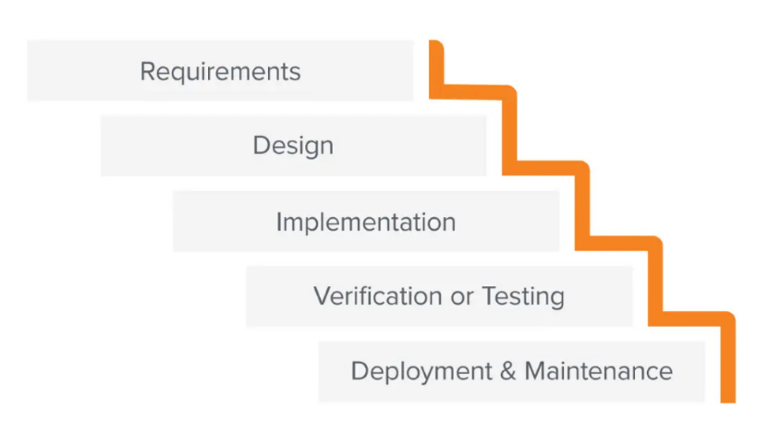
I will be using the waterfall methodology for my project management since I will be working phase by phase; once a phase is completed, I will move on to the next.
Figure 1
Waterfall methodology steps

As the figure above shows, the first step will be to determine the requirements needed for my system, which will be done in this report, the documentation. The second step is the design, in which I will show the functions of the system using the use case diagram and the class diagram to view the objects needed in the system and the user interface design to show how the application will look to the end user. In the third step, I will be implementing the frontend and backend with the specified technologies specified in the documentation. Last but not least is the testing, which will be the part where the system either succeeds or needs more work. If the testing needs more work, I will start all over since I will be modifying the rest of the steps. Types of testing I will be integrating into the system are functional testing, performance testing, automated testing, usability testing, and security testing. Finally, the deployment will be the final phase, in which every previous phase must be successfully completed in order for it to be effective.

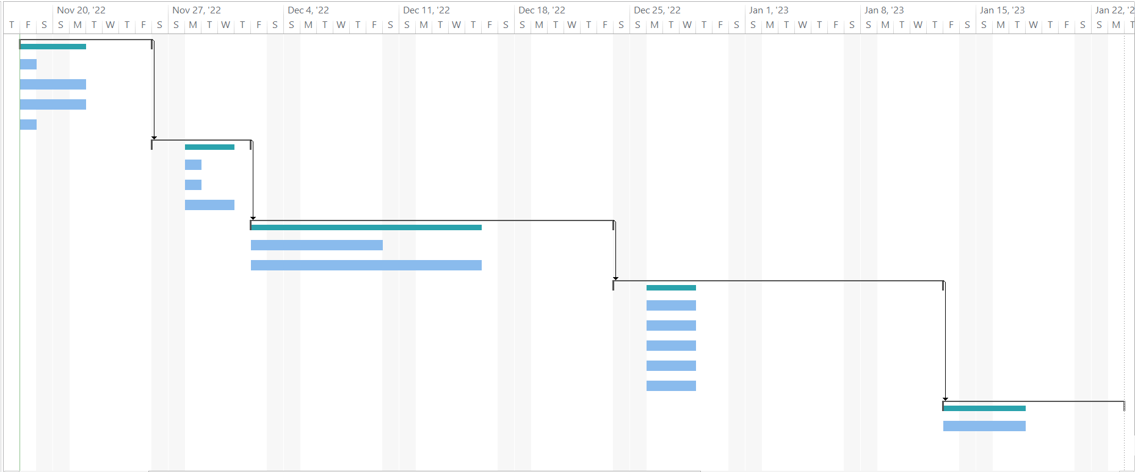
Work Plan (Gantt Chart)
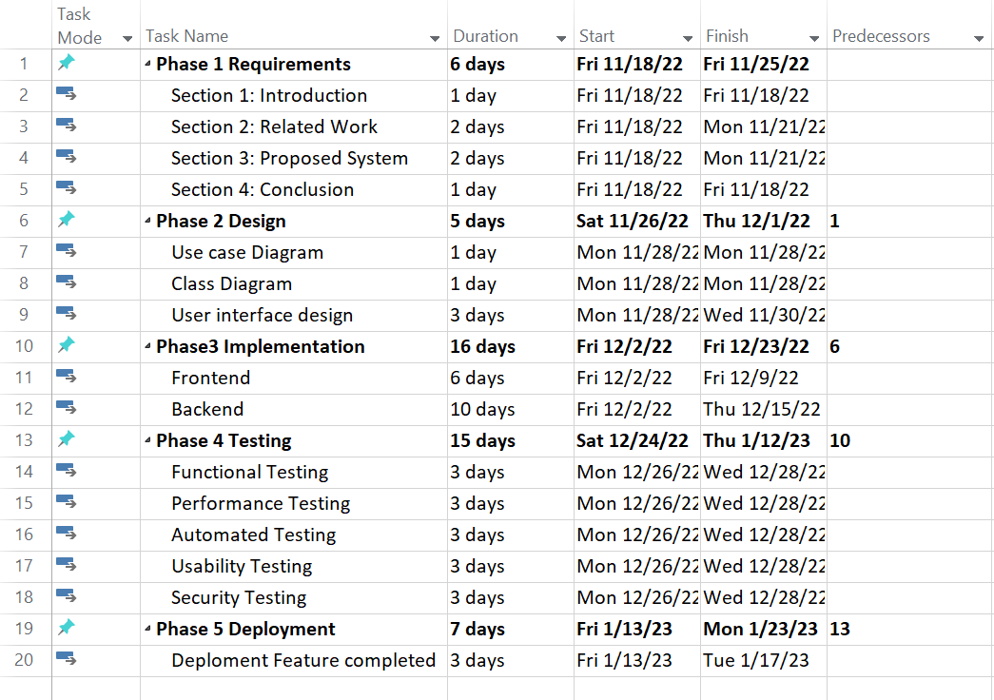
Figure 2
Gantt Chart

Related Work (State-of-The-Art)
In this section, I will discuss existing systems as well as the work of other colleagues who implemented the system using different or the same approaches.

Background
Other colleagues' approaches in their researchers mostly use fake objects and data allocation strategies, but in a different way than the system I will be implementing. My system will have the approach of allocating data and adding fake objects, but the injection of fake objects will occur before any agent is requesting the data. The admin will then distribute the data to agents if it is a scheduled distribution or distribute it per agent request. The system technologies will be integrated into a cloud platform, and all files will be saved in MongoDB and connected to the platform.

Literature Survey
Chaube, D. et al. (2015) [1] this paper conducts model that include detecting guilty agent by allocation strategies and to calculate the probability of guilty agent by agent guilt model.
Yashwant, W. and Patil, B. (2016) [2] this paper detects guilty agent with guilt probability model and injects fake objects, in addition, K-anonymity algorithm creates sensitive data on therefore the data set will be hidden from third parties.
Reddy, S.C. et al. (2019) [3] this paper presents data allocation strategies to identify the guilty agent and uses explicit data requests algorithms to distribute fake objects on the data.
Kumari, A. et al. (2019) [4] this paper conducts data allocation strategies where their methods don’t use watermark instead adding fake objects to their data.
Okochi, P.I., Okolie, S.A. and Odii, J.N. (2021) [5] this research achieves detecting and preventing data leakage using OOAD methodology and to monitor any activities that happen inside or outside the organization with their date and time stamp.
Bavachkar, S.G. and Pawar, S.N. (2022) [6] this research also uses guilt agents’ model and it introduces algorithms to distribute objects to agents by adding fake objects.

Analysis of the Related Work
"Implementation of guilt model and allocation strategy for data leakage detection," issued in 2015 by Divya, Sonali, Priyanka, and Rajesh. This paper uses a data allocation strategy that explains how to distribute the data intelligently to the agent and add fake objects as a kind of trace. Moreover, they use the agent guilt model to estimate the probability of detecting the guilty agent. Their system uses a lot of algorithms to allocate data, including E-optimal, E-random, Random, S-random, and S-overlap, and the distributor is the one that chooses the algorithm, as shown in Figures 3 and 4 below [1].
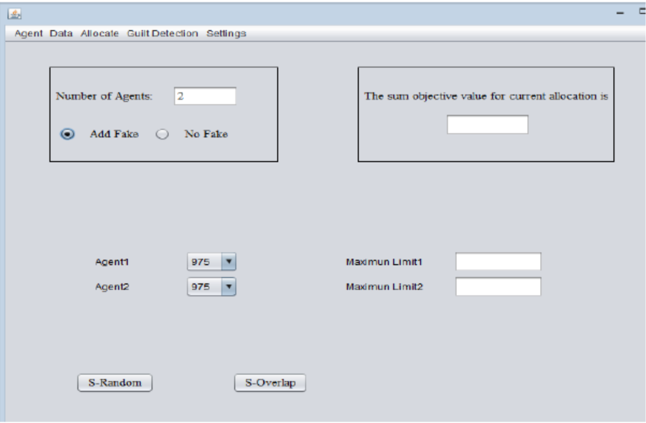
Figure 3 [1]
Proposed system
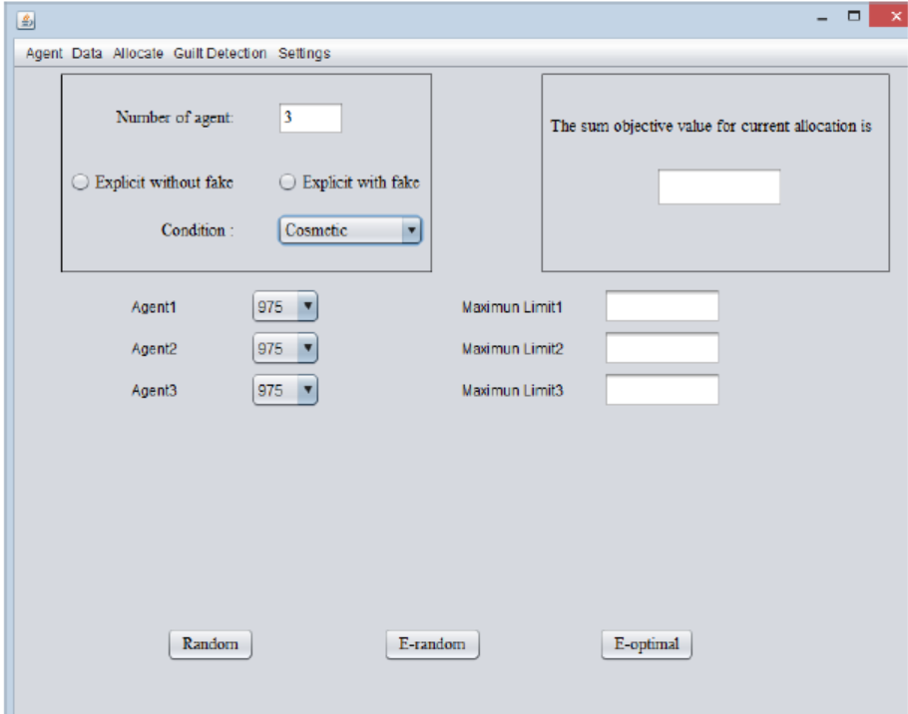
Figure 4 [1]
Proposed system

Furthermore, they discussed each algorithm either for the sample data or the explicit data. They stated the creation of fake objects must be limited so it will not raise suspicion among agents, and for the agent to not discover the fake object, a real object must already be available. While for the allocation strategies, there were constraints to allocate: "there should be a minimum overlapping between two agents" and "there should be a maximum difference between guilt probabilities." [1]. Pseudo code was also shown to understand the algorithms that will be used either for the explicit or the sample (Figure 5 for the explicit and Figure 6 and 7 for the sample).
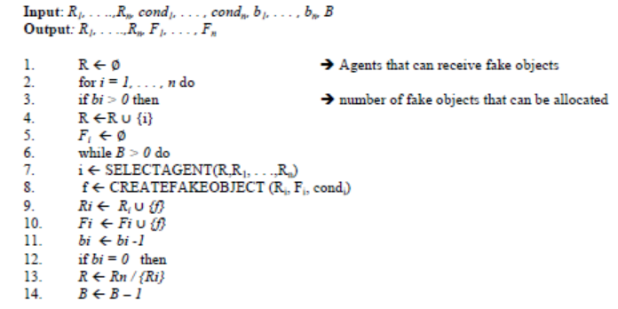
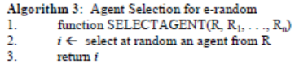
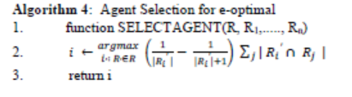
Figure 5 [1]
Explicit data request

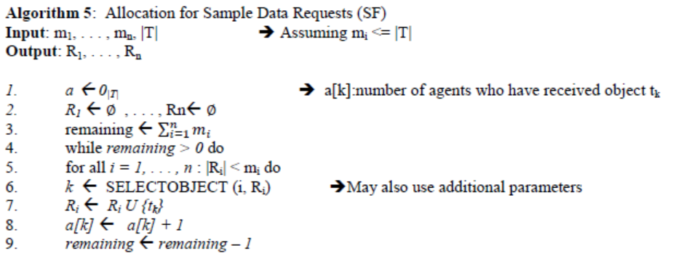
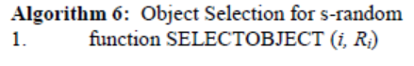
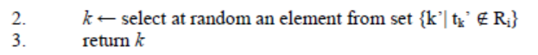
Figure 6 [1]
Sample data request
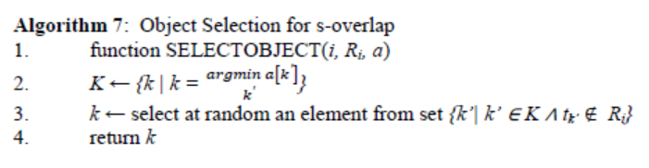
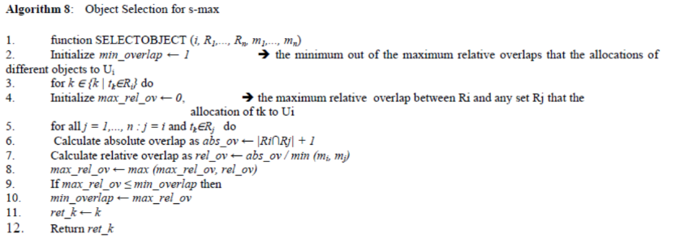
Figure 7 [1]
Sample data request

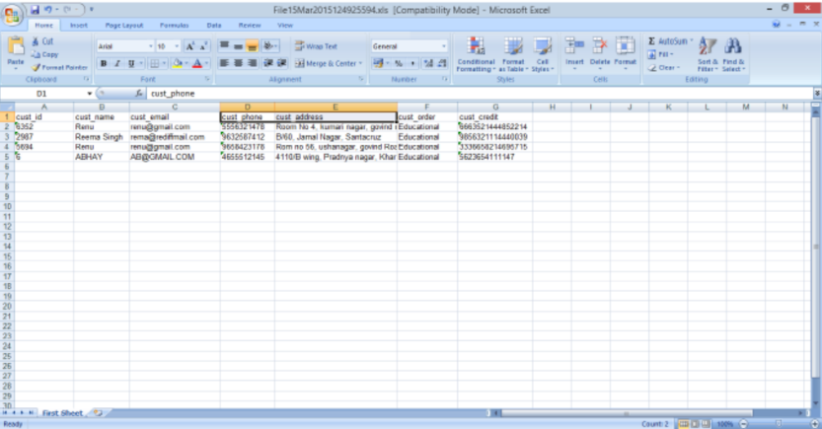
Finally, they also viewed the output from the estimation of the probability of agent guilt in an Excel sheet, as shown below in Figure 8, where the guilty agent details appear.
Figure 8 [1]
Results of guilty agent probability

In a 2016 paper written by Dr. Babasaheb called "Data leakage detection with the K-Anonymity Algorithm," he proposes techniques to reduce the watermark drawback by creating fake objects and allocating data, and to detect the guilty agent, a probability model is introduced in the proposed system section. To improve the effectiveness of detecting, he will be putting on the data fake objects to the data and suggesting that this is better than perturbing the data because "fake objects may cause fewer problems than perturbing real objects" [2]. Furthermore, this paper focuses on "intelligently" giving agents fake objects, either sample tuples or explicit objects depending on the requests. Babasaheb also showed in a figure the instances of the requests shown below in Figure 9.
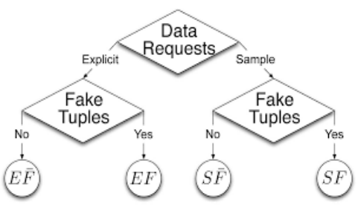
Figure 9 [2]
Data Requests
This figure illustrates the sample
and explicit fake objects and
how it will be managed.

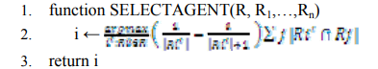
Explaining the explicit request or EF as shown in the figure above, for explicit with no fakes, the distributor cannot add fake objects to distributed data; they are only added at the request of the agent, while for explicit with fakes, the distributor adds the fake object to a set of requests with different conditions. He used an algorithm called e-optimal, which adds fake objects to the most eligible agent function shown in the below picture, Figure 10.

Figure 10 [2]
E-Optimal algorithm for explicit request

On the other hand, the sample request, which estimates the probability of guilty agents, gives a sample of data to the agent’s request and detects who leaked that data (Figure 11).
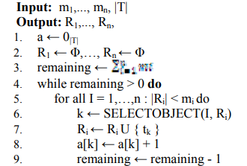
Figure 11 [2]
Sample data request

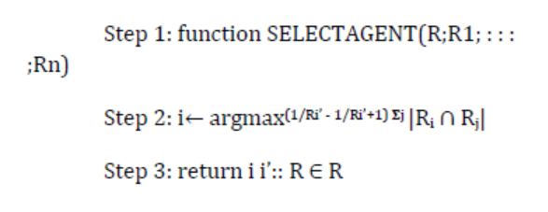
Sai, Venkata, Gopal, Raji, and Dr. Vijaya issued a paper titled "Data Leakage Detection using Cloud Computing" in 2019 where they also speak about data allocation strategies that add fake objects based on the data requests sent by the agents, whether they are explicit or sample data requests. They also stated many algorithms to allocate data, all of which are used in their system, which are E-optimal, E-random, S-random, S-overlap, and S-max. Each of those algorithms adds fake objects after identifying the data request; if it’s explicit, then the allocation of fake objects will be followed; they will find the most suitable agent and add the fake object to the data that he or she has requested, as illustrated below in Figure 12. On the other hand, if the data request is a sample, then S-max will be the algorithm to use; it will take the agent with the minimum overlap among any pair of agents, as demonstrated in Figure 13 [3].
Figure 12 [3]
E-optimal algorithm
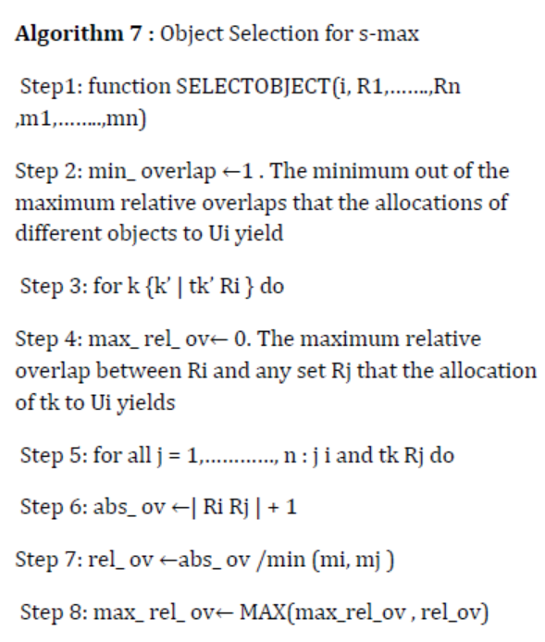
Figure 13 [3]
S-max algorithm
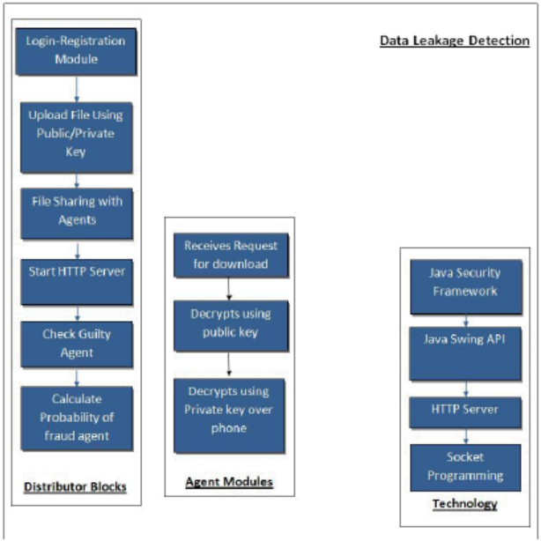
Furthermore, their proposed solution, as illustrated in Figure 14 below, shows that the distributor will share files with agents and check for a guilty agent with a probability of guilt. While for the agents, their functionalities are to request to download files, decrypt using a public key, and decrypt using a private key using a phone.

Figure 14 [3]
System Layout


Another paper called "Analysis of data leakage detection techniques using cloud computing environments" was written by Ankita, Rupali, Shivani, Nikita, and Hande in 2019. This paper uses the data detection module with four module specifications: the data allocation module, the fake object module, the data distributer module, and the agent guilt module. In the data allocation module, admin, the distributor, can send files to the authenticated user [4]. Agents in this paper are specified as those who can view the secret key to detect the guilty agent. and uses fake objects as a trace, in which the distributor creates the fake object in the data but has a limited number of fake objects to create. The paper uses some operational examples to visualise the data allocation, which you can see in figure 15 below.
Figure 15 [4]
Data allocation algorithm

Secondly, the fake object module is where fake objects are added on the data by the distributor . They are using fake objects as traces in records. "In case the wrong secret key is given to download the file, the duplicate file is opened, and the fake details also send the mail Ex: The fake object details will display." [4]. To show the algorithm used in the fake object module, it is illustrated in Figure 16.

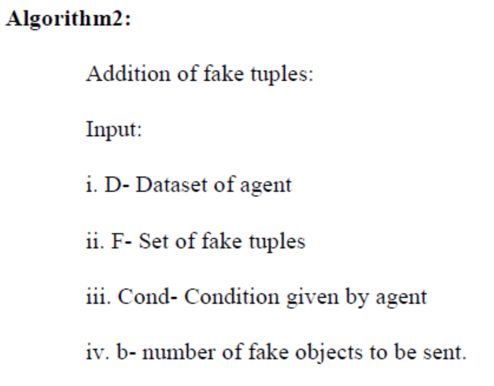
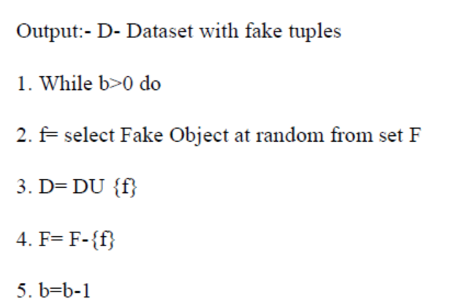

Figure 16 [4]
Algorithm for fake object module

In the data distributor module, it just states the situation of the leak and why the distributor tends to distribute fake objects. Furthermore, the last module used is the agent guilt module, which estimates the probability of an agent having multiple fake objects and, after some calculations, refers to an agent as a "guilty agent."

In 2021, Prisca, Stanley, and Juliet wrote a paper called "An improved data leakage detection system in a cloud computing environment" that states the methodology used for their proposed system, which is object-oriented analysis and design because they have different objects, and this methodology can develop a graphical model for the lifecycle of the software [5]. As shown in Figure 17 below, the system architecture shows that there will be a cloud that stores the database and an audit trail that will check the activities of each process. Moreover, the administrator will register each user with their roles, which include distributor, administrator, and user. "The distributor uploads new files into the system, approves them, sends key requests to the user, and also shares files with each user." [5].
Figure 17 [5]
System architecture

They used the audit trail to check if the user sent files outside of the organisation with a date and a time stamp. They also showed in figures the difference between having an audit trail and not having one, as shown in Figures 18 and 19.
Figure 18 [5]
Graph of entries without transaction log/ Audit trail [5]

Figure 19 [5]
Graph of entries with transaction log/Audit trail [5]

The graph shows that in figure 18 the user activities are not traced with any mechanism while for figure 13 it shows that each entry will be shown and traced in the audit trail.

Finally, in 2022, "Data leakage detection using algorithms," written by Seema and Swati, states five modules: data allocation, fake object optimization, data distribution, and guilty agent module. Data allocation and fake objects were discussed in the previous papers, but the others have not been discussed before. In the optimization module, they stated that the agent will have one constraint and the distributor will have one objective. The constraint is that agents must "satisfy the distributor’s requests" [6], and the objective is to manage to detect the agent that leaked the most data. While for the data distributor module, they only stated that the admin (distributor) will “view which file leaked and the fake user’s details” [6]. Lastly, in the guilty agent module, they have used perturbation, stating that it’s the best technique since it makes the data less sensitive before distributing it to any agent. They also graphed their system architecture to better visualise the system (Figure 20).
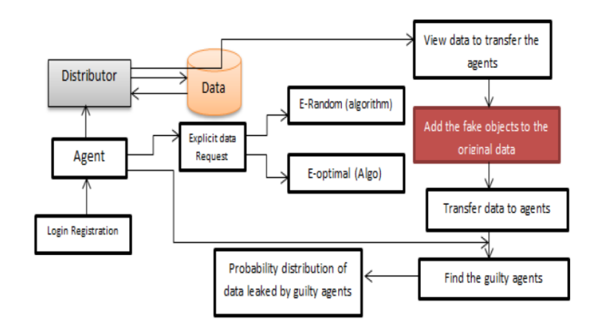
Figure 20 [6]
Proposed system algorithm
This figure shows the algorithms
that will be used in their proposed system
Year | Techniques | Algorithms | Advantages | Disadvantages
Chaube, D. et al. (2015) [1] | Data allocation strategy where fake objects are added to either explicit or sample data request and guilty agent model. | E-optimal  E-random  Random  S-random  S-overlap | Makes the system more efficient since it handles the sample and explicit data requests. Also, the distributor chooses which algorithm he she wants to use. | The distributor must have good knowledge of each algorithm to know what he or she is doing, so this system is not for everyone.
Yashwant, W. and Patil, B. (2016) [2] | Data allocation strategy where fake objects are added to either explicit or sample data request. | K-anonymity | This algorithm has high efficiency to detect the guilty agent. | It is hard to share information among agents, which will result in more requests for the same data.
Reddy, S.C. et al. (2019) [3] | Data allocation strategy where fake objects are added to either explicit or sample data request and guilty agent model. | E-optimal  S-max | Makes identification more accurate. | Uses other algorithms to maintain the use of the specified algorithms so it will have high time complexity
Table 1
Advantages and disadvantages

Kumari, A. et al. (2019) [4] | Data allocation strategy where fake objects are added to only sample data requests. | S-max | It checks if the agent has one or more overlap and depending on that it adds fake object. | The agents can collaborate and identify the object, since this how the overlap works that it gives the agent an object that was given to the smallest number of agents.
Okochi, P.I., Okolie, S.A. and Odii, J.N. (2021) [5] | Data allocation strategy where fake objects are added to only explicit data requests. | E-optimal  E-random | The distributor can add a fake object to the agent he or she believes is the guilty agent with e-optimal. | E-random is a weak algorithm since it allocates fake objects randomly to any agent.
Bavachkar, S.G. and Pawar, S.N. (2022) [6] | Data allocation strategy where fake objects are added to only explicit data requests. | E-optimal  E-random | The distributor can add a fake object to the agent he or she believes is the guilty agent with e-optimal. | E-random is a weak algorithm since it allocates fake objects randomly to any agent.
Table 1
Advantages and disadvantages

To summarise Table 1 above, the drawbacks of the papers of past researchers are mostly due to the algorithms used rather than the techniques. So, in my system, I will allocate the fictitious objects on the data using a different algorithm, T-closeness. This algorithm can be used in the worst-case scenario if the data has been leaked. It tracks data on the defined threshold, which refers to the distance of the data; if the data is further away than the threshold, we can notify the administrator. Table 3 will be used to demonstrate the comparison of the strategies.

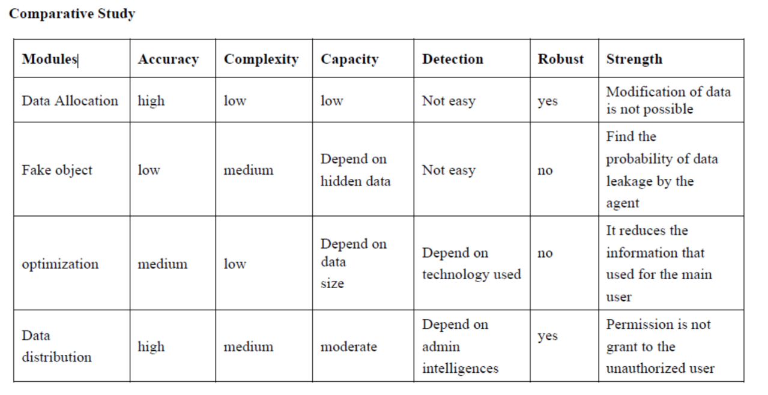
Table 3 [7]
Comparative study

The table above shows that the data allocation has the highest accuracy, which makes it the most important step in detecting data leaks. That is why I will be using the data allocation and fake object modules to have the highest accuracy and to find the probability of data leakage by the agent.

Proposed solution
As we saw in the previous section, the works of some of the colleagues, the analysis of each work, the approaches they stated and used in their system, and some demonstration of the advantages and disadvantages. In this section, I will go over my system in detail and the features it will have.

Solution Methodology
For my data leakage detection system, I will be using different approaches. I will be injecting all the files with fake objects “realistic but fake” and then the distribution begins. The admin will distribute the files to the agent that requested them. After the agent receives the files, he or she can login with their predefined username and password to view or share the data. Furthermore, there will be a count for each fake object, and when it exceeds a certain count, for example, one week, then the fake object will be renewed for each set of data that is distributed. As a result, any agents who work together to find the fake object will find this approach difficult. Additionally, since the fake objects act as traces to the data, I will be tracing the objects with an audit trail, which will audit each log and each action that the agent is taking. Furthermore, I will be saving each agent with their corresponding fake object for more effectiveness in detecting the guilty agent, so if the audit trail notifies the user of a guilty agent, there will be another piece of evidence that the fake object is corresponding to that agent. If the agent wants to share the file, the audit will track the sharing; if he or she tries to share with someone outside the organization, the admin (distributor) will be alerted immediately via email and in the admin profile. All files will be saved in MongoDB and connected to the cloud platform.

Functional/ Non-functional Requirements
Functional Requirements:
Employees:
- Login: they will login with predefined username and password
- View files
- Share files within the organization

Admin:
- Logging in: they will login with their own username and password.
- Sending files to agents
- Viewing the audit log

Non-functional Requirements:
- Performance: the system must detect guilty agent in range of 0.02 seconds.

- Scalability: the system should handle a lot of requests at same time with the same rate if one request is available.

- Security: the system should secure private information (files, usernames, password, fake objects)

- Reliability: the system must have a critical failure less than 2% and must be fixed in less than 5 seconds. Since the organization using the system could have attacks when it’s in critical position.

- Readability: the system should have an audit trail that an admin can understand and read.

- Usability: the user, either the admin or the employee, must feel at ease while using the system so the system must not have a lot of restrictions in the user’s interface all must be done in the backend.

Conclusions and Changes

Summary
To finalise the report, I have adjusted some of the drawbacks of the other researchers' implementations of the algorithms or technologies used. Injecting fake objects into the data before distributing it to the agents helps in detecting the guilty agent with ease. In addition, to prevent any agents from collaborating to identify the fake objects, I will be updating the fake objects weekly for the distributed files. Any suspicious action from any agent will be monitored by an audit trail. The audit trail will function as an agent guilt model, tracking the fake objects used as traces to detect if any agent is attempting to send it to an external organisation and notifying the admin with the details of the guilty agent. Finally, sharing between agents is possible but will also be tracked with an audit trail.

Changes
No changes

References

- Chaube, D. et al. (2015) Implementation of guilt model and allocation strategy for data ... – IJSRP Available at: http://www.ijsrp.org/research-paper-0415/ijsrp-p4090.pdf (Accessed: November 24, 2022).
- Yashwant, W. and Patil, B. (2016) Data leakage detection with K-anonymity algorithm - IJCSIT. Available at: https://www.ijcsit.com/docs/Volume%207/vol7issue4/ijcsit2016070453.pdf (Accessed: November 24, 2022).
- Reddy, S.C. et al. (2019) “© 2019, IRJET | Impact Factor value: 7.211 | ISO 9001:2008 Certified Journal | Page 6939 DATA LEAKAGE DETECTION USING CLOUD COMPUTING,” DATA LEAKAGE DETECTION USING CLOUD COMPUTING, 6(3), pp. 6939–6945.
- Kumari, A. et al. (2019) Analysis of data leakage detection technique using cloud computing ... Available at: http://www.ijics.com/gallery/40-mar-984.pdf (Accessed: November 24, 2022).
- Okochi, P.I., Okolie, S.A. and Odii, J.N. (2021) “An improved data leakage detection system in a cloud computing environment,” World Journal of Advanced Research and Reviews, 11(2), pp. 321–328. Available at: https://doi.org/10.30574/wjarr.2021.11.2.0385.
- Bavachkar, S.G. and Pawar, S.N. (2022) Data Leakage Detection Using Algorithms, 11(6), pp. 874–878. Available at: https://www.ijarse.com/images/fullpdf/1656056919_8213.pdf
- Kumar, V. and CR, M. (2022) A Review on Identifying Data Leakage Using Guilt Agent, 13(3), pp. 4742–4746. Available at: https://publishoa.com/index.php/journal/article/view/1316/1126
- F. Twum and J. Ben, “Detecting Data Leakage in Cloud Computing Environment (A Case Study of General Hospital Software),” www.academia.edu, Accessed: Oct. 15, 2022. [Online]. Available:https://www.academia.edu/29031004/Detecting_Data_Leakage_in_Cloud_Computing_Environment_A_Case_Study_of_General_Hospital_Software_

